**Area under curves (Quadrature)**

Our concentration in this Chapter is to find the area bounded by curves with a general formula or with the help of definite integration. This process is called Quadrature.

**Area formula for Cartesian equation:**

**(1).** The area bounded by the curve , the -axis and the lines andis,





Where, is a continuous single valued function and it does not change sign for .

**(2).** The area bounded by the curve , the -axis and the lines andis,





Where, is a continuous single valued function and it does not change sign for .

**(3**). The area bounded by two curves, and two vertical lines is

.

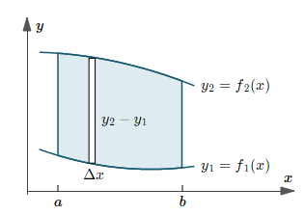

**(4).** The area bounded by the curve Symmetry about the -axis is,



**(5).** The area bounded by the curve Symmetry about the -axis is,



**Symmetry about the -axis:** If all the powers of *y* occurring in an equation are even then it is symmetry about the ****-axis. For example,  is symmetry about the ****-axis.

**Symmetry about the -axis:** If all the powers of *x* occurring in an equation are even then it is symmetry about the ****-axis. For example,  is symmetry about the ****-axis.

**Mathematical Problems**

**Problem 01:** Find the area bounded by the curve , the and the straight lines and .

**Solution:** We have, and.

The graph of the given curve is,

Y

X



O





The area of the region is,















** Sq. Units.**

**Problem 02:** Find the area bounded by the curve , the and the straight lines and .

**Solution:** We have, and.

Y



X

O





The graph of the given curve is,

The area of the region is,













** Sq. Units.**

**Problem 03:** Find the area bounded by the curve , the and the straight lines and .

**Solution:** We have, and.

The graph of the given curve is,

Y



X

O





The area of the region is,













** Sq. Units.**

**H.W:**

**1.** Find the area bounded by the curve , the and the straight lines and .

**2.** Find the area bounded by the curve , the and the straight lines  and .

**3.** Find the area bounded by the curve , the and the straight lines  and .

**Problem 04:** Find the area of the region bounded by the curve ; from and .

**Solution:** We have, and .

Since, only even power of *y* occurs in the given curve so the curve is symmetric about the *x*-axis.

The graph of the given curve is,

Y



X

O



Also, the given curve can be written as,





The area of the region is,

















** Sq. Units.**

**Problem 05:** Find the area of the region bounded by the curve  and *y*-axis.

**Solution:** We have,

Since, only even power of *y* occurs in the given curve so the curve is symmetric about the *x*-axis.

The graph of the given curve is,

Y



X

O







Putting in (1) then we have  , so the vertex is at .

Also putting in (1) then we have. So the curve crosses the *y*-axis at and The given curve can be written as,





The area of the region is,

















** Sq. Units.**

**H.W:**

1. Find the area of the region bounded by the curve ; from and .

2. Find the area of the region bounded by the curve ; from and .

**Problem 06:** Find the area of the region enclosed by  and.

**Solution:** The equation of the given curves are  and.

The graph of the given curves are as follows:

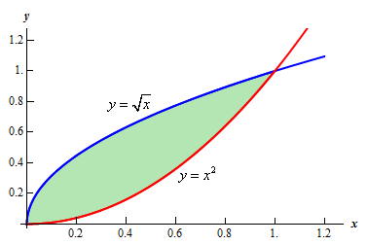

We have

 and

Now,



 [Squaring both sides]







Therefore,  and 











For real we get respectively 

Therefore, the given curves intersect each other in two point at and.

In the question, **.**

So, the area of the region is,



















** Sq. Units. ( As desired)**

**Second Process:**

Solution:

The equation of the given curves are  and.

The graph of the given curves are as follows:



We have

 and

Now,



 [Squaring both sides]







Therefore,  and 











For real we get respectively 

Therefore, the given curves intersect each other in two point at and.

In the question, **.**

So, the area of the region is,



















** Sq. Units. (As desired)**

**Note:** It is noted that when we calculate the area with respect to x or y axis we get the same result.

**Problem 07:** Obtain the area of the region enclosed by  and.

Solution:

The equation of the given curve is  and also the straight line is.

The graph of the given curve and straight lines are as follows:

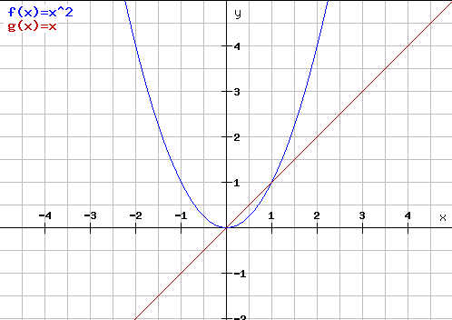

We have

 and 

Now,







Therefore, 



For real we get respectively.

Therefore, the given point of intersection of curve and straight lines are and.

In the question ,**.**

So, the area of the region is















** Sq. Units. (As desired)**

**Problem 08:** Determine the area of the region bounded by  and.

Solution:

The equation of the given curve is  and also the straight line is.

The graph of the given curve and straight lines are as follows:

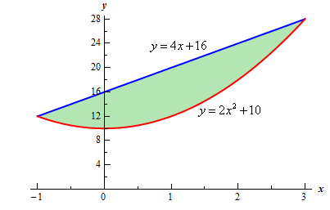

We have

 and 

Now,















Therefore 



For we get respectively.

Therefore, the given point of intersection of curve and straight lines are and.

In the question, **.**

So, the area of the region is























** Sq. Units. (As desired)**